Investigative Science Exam 1 Study Guide

Topics You Need to Know:

* Scientific Method (~30%)
* Graphing (~20%)
* Measurements (~30%)
* Lab write-ups (~15%)
* Big Bang Theory (~5%)

1. What is the scientific method used for?
2. List and define the six steps of the scientific method

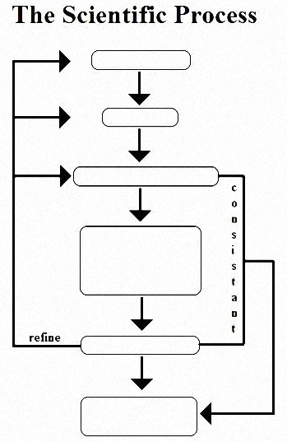

1. What are the two different types of reasoning?
2. What are the two groups in an experiment?
3. What are independent variables? Dependent variables? Make sure you can identify them in a given scenario
4. What is the difference between a hypothesis, a theory, and a law?
5. What are graphs and why do we use them?
6. Know the different types of graphs: charts/tables, pie graphs, bar graphs, and line graphs/scatter plots. Be able to interpret the data
7. What is correlation? How can you tell if something is correlated?
8. Which variable goes on which axis?
9. What do all graphs need? (TALKS)
10. What are SI units? Which unit is used for which measurement?
11. What are the SI prefixes? Can you list them in order from smallest to largest?
12. How do you convert from one measurement to another (its equivalent)? Make sure you are able to do so!
13. What is the difference between accuracy and precision?
14. Which instrument do we use to measure length? Temperature? Volume? Mass?
15. What is the Big Bang Theory?
16. What two units do we use to measure distances in space? What is the difference between them?
17. What are the steps of the Big Bang Theory?